RudraDave Lab3

Using the CICD for Python Application (incl Ansible Deployment) section from class 9 as your guide, you will create CI and CD pipelines for this Python API

The following repos are used in this lab. Fork these into your own GitHub account

Repo: JenkinsComplex

Repo: ContinuousDelivery

Repo: ProvisionAppServer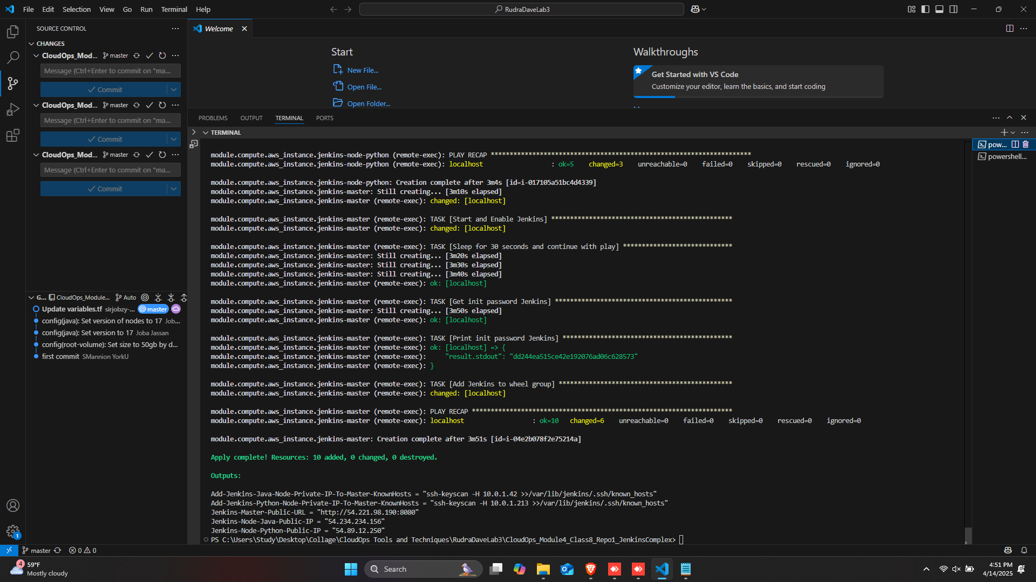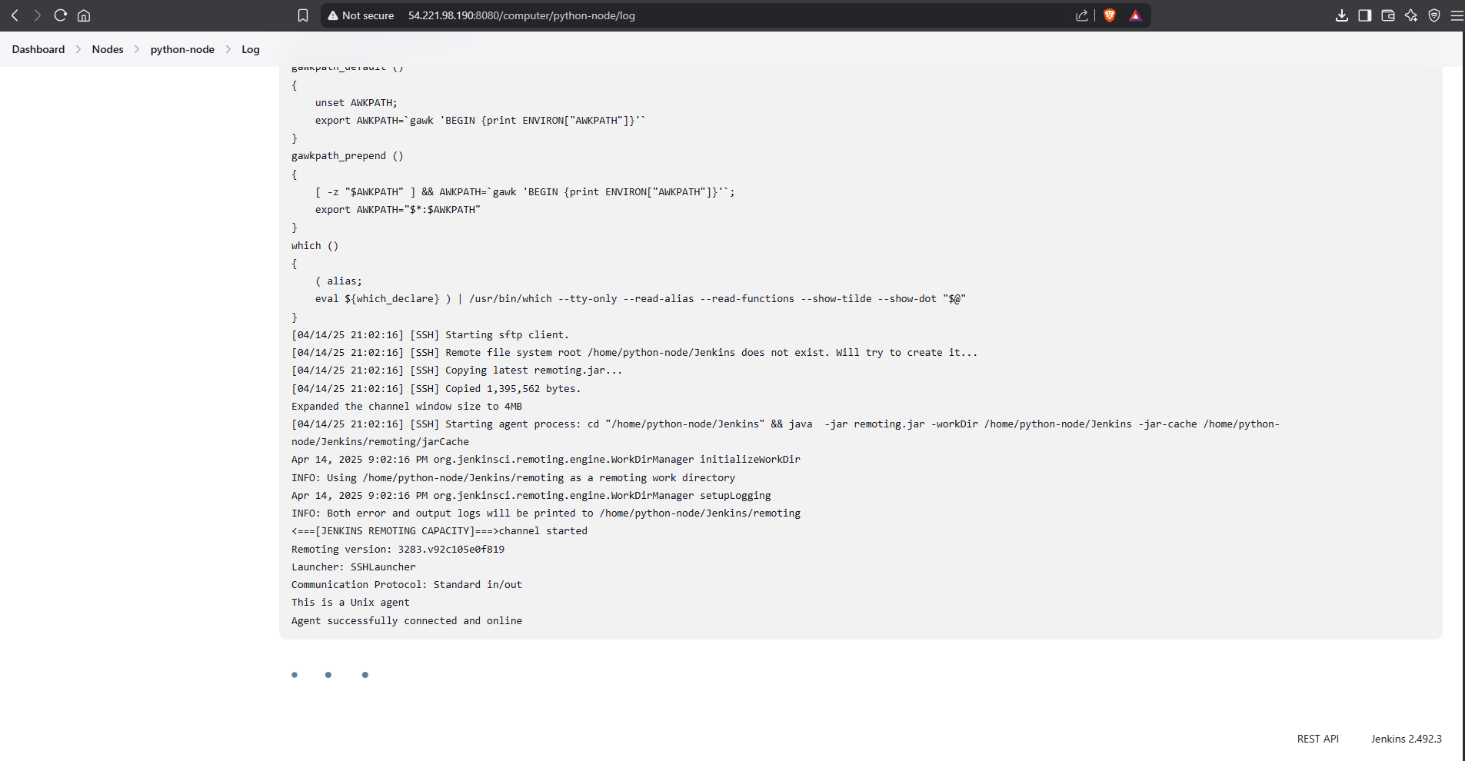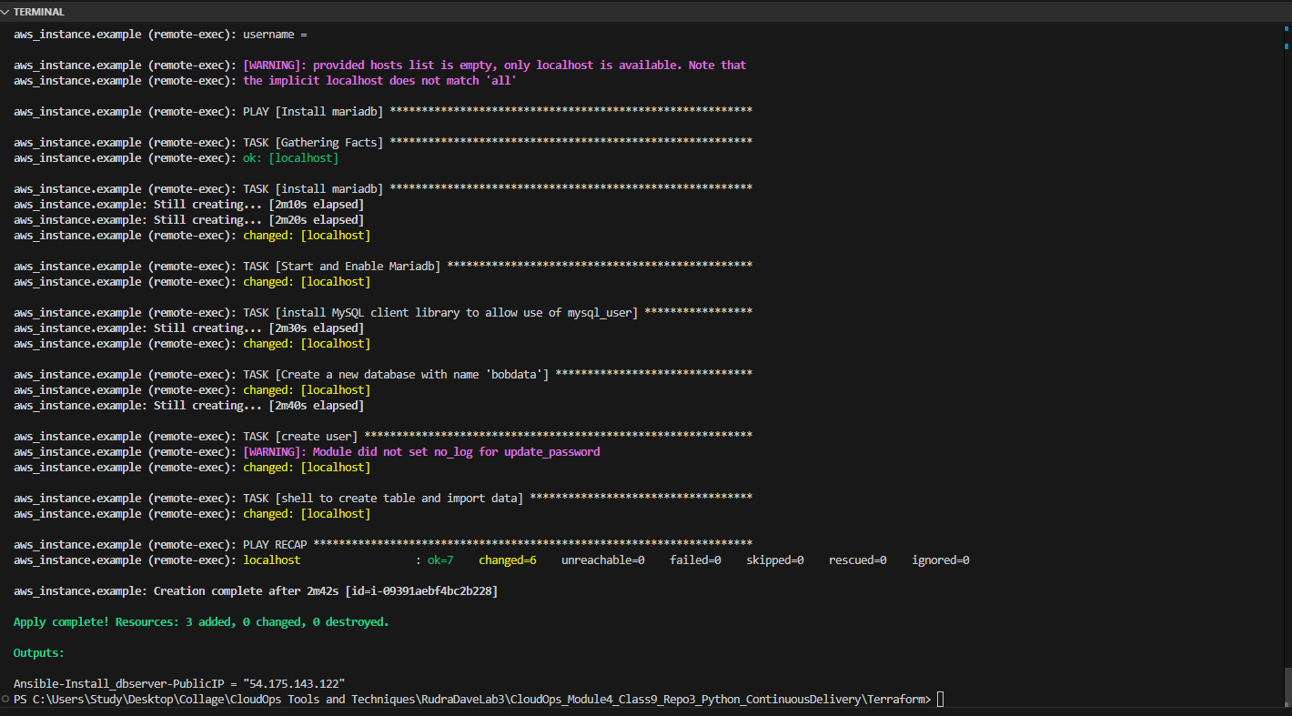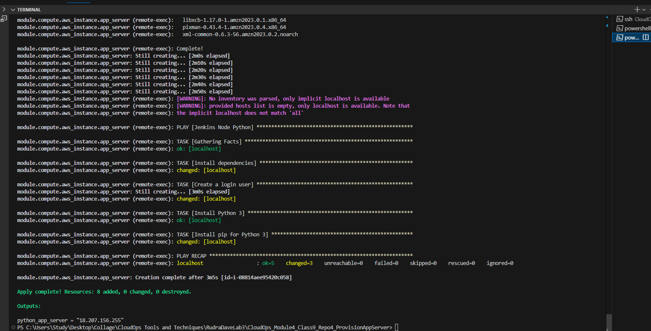

First PIPE Line Build Output

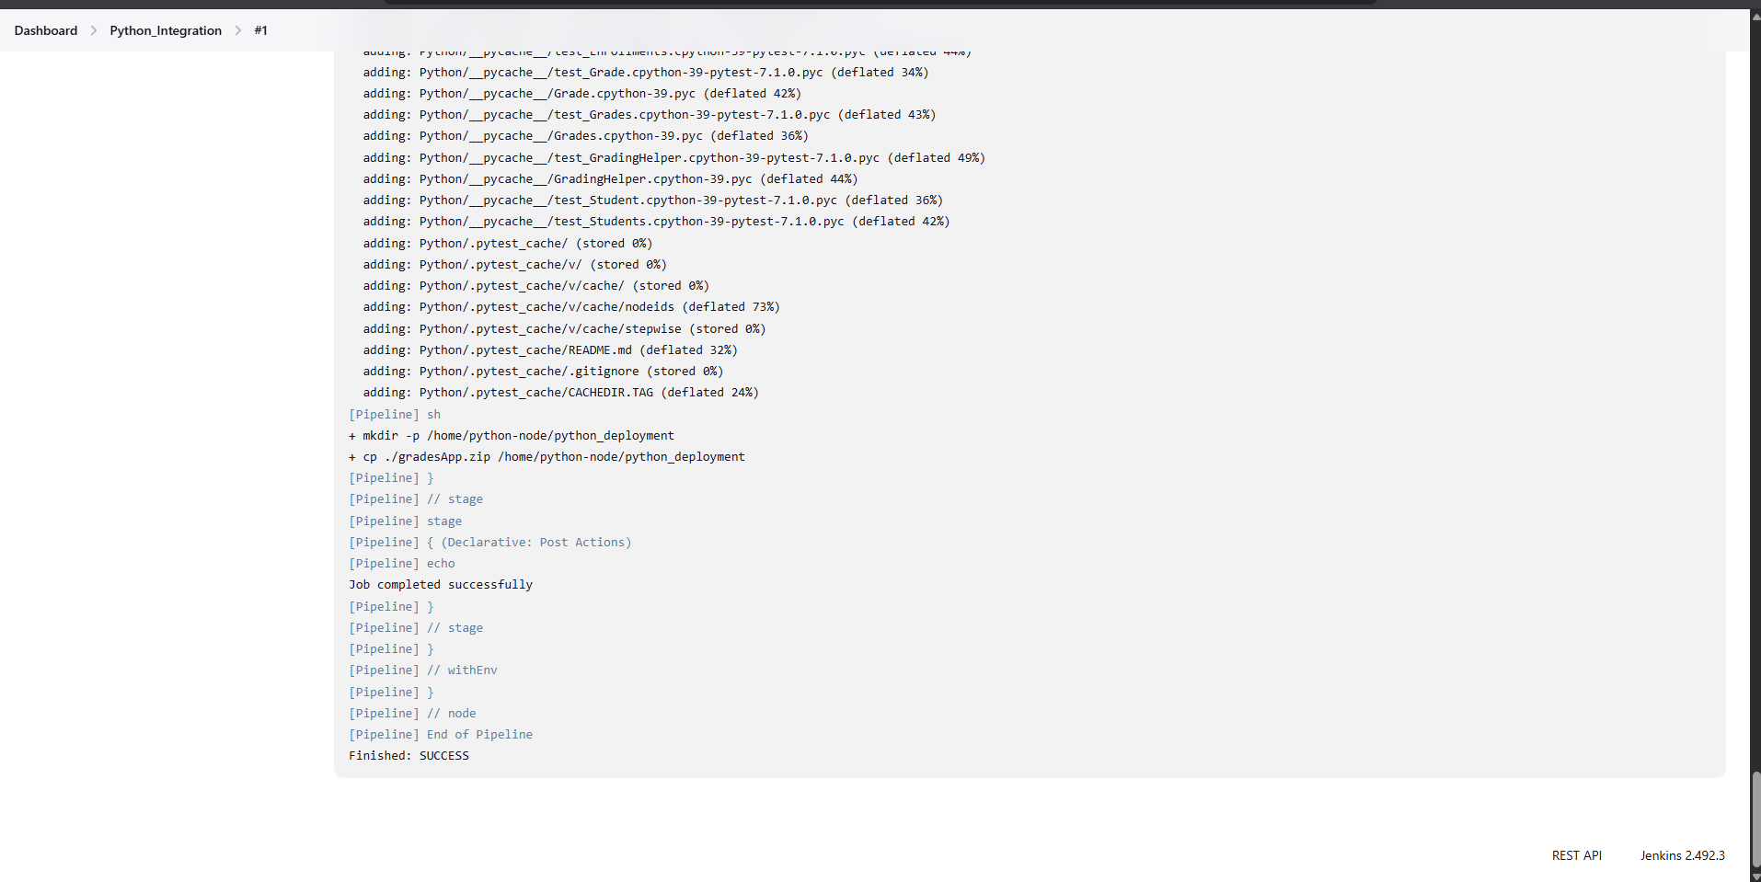

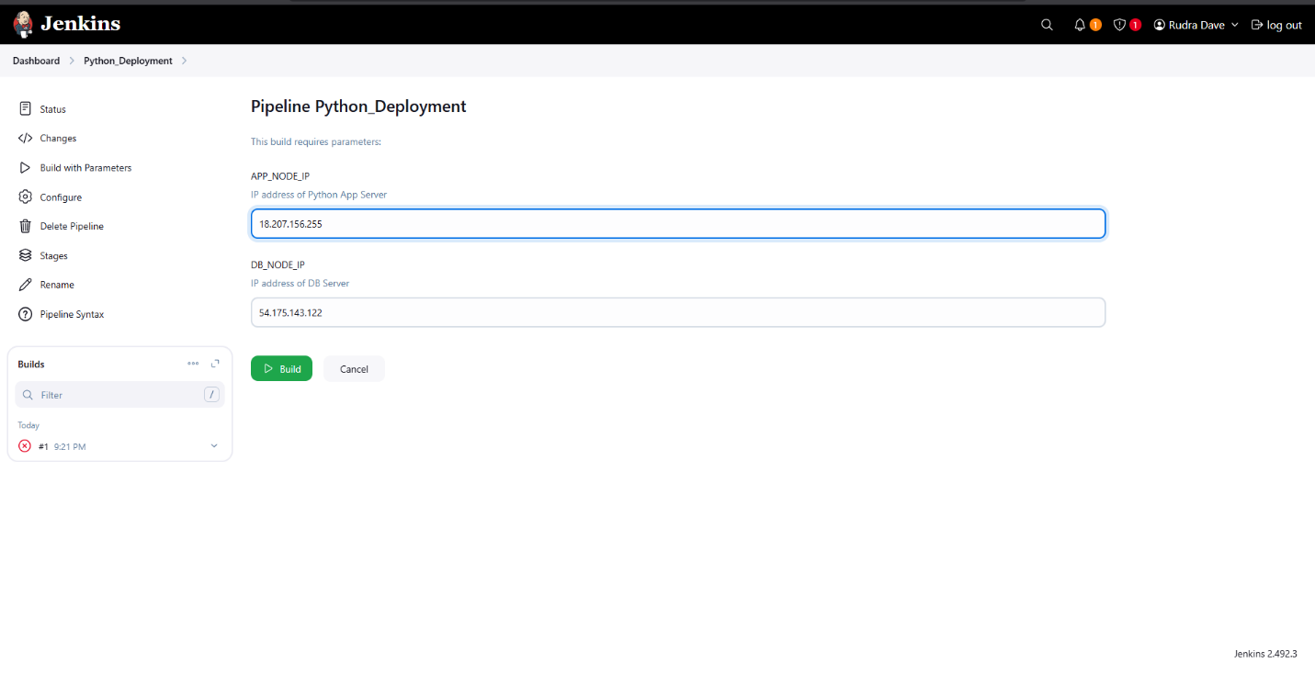

Second PIPE Line Build Output

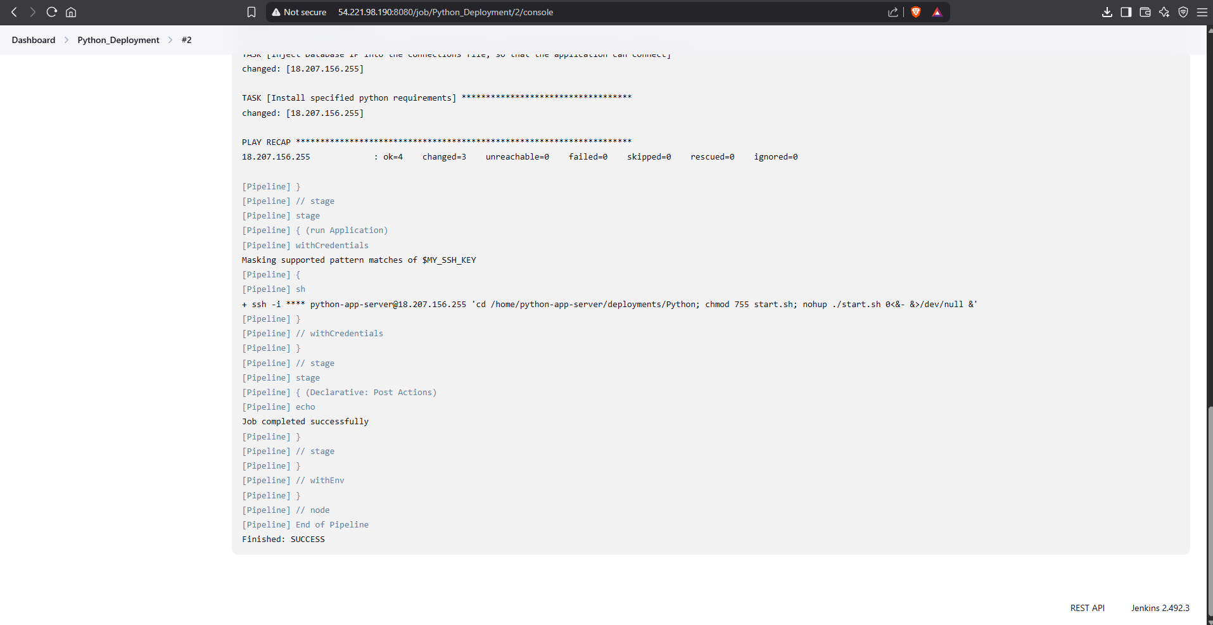

Listing Student Detail on terminal

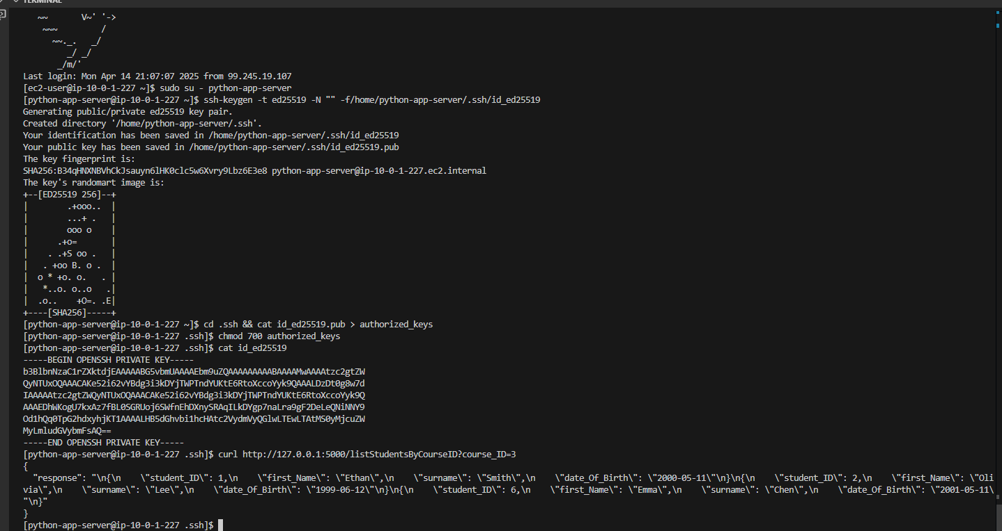

All Runnning Instances in AWS

